***PROGRAMMING FUNDAMENTAL***



Subject Name: PROGRAMMING FUNDAMENTAL

Class Id :110802

STD Id :65516

Student Name: M SALMAN

Teacher Name: SYED FAROOQ AHMED ZAIDI

Date: 06/11/2022

# ASSIGNMENT # 1

**Problem 1: Miles per hour to kilometers per second.**

Mr. Bhola does not know how to convert between miles/hour to kilometers/seconds. Write a program that asks for speed in miles/hour and outputs the speed in kilometers/seconds.

***Flowchart:***

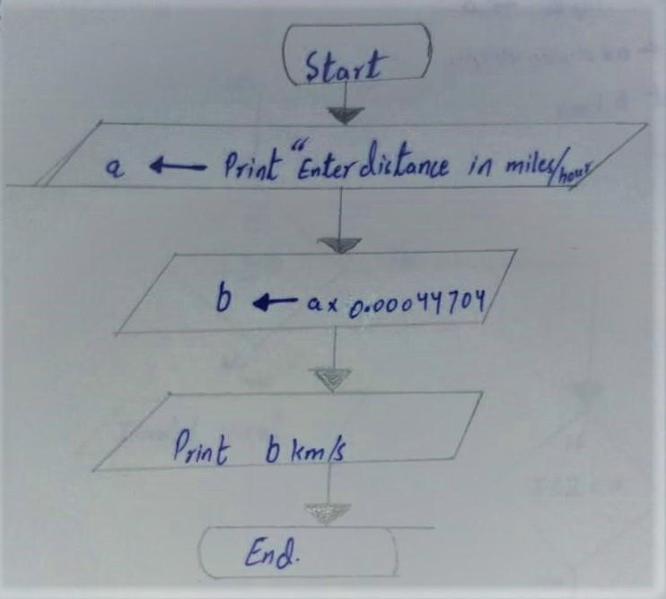

***Pseudocode:***

1. Start
2. Print “Enter Velocity in Miles per Hour”
3. Read input a
4. b a* 0.00044704
5. Print b Km/s
6. End

***Problem 2: Even or Odd.***

Mr. Bhola does not know what an even or odd number is. He is least bothered to learn the difference either. It all comes down to your programming skills to write a program that will ask for a positive integer greater than 0 and prints whether the number is even or odd. Be careful, Mr. Bhola can even enter 0 or negative numbers so your program must give an error saying invalid input in that case.

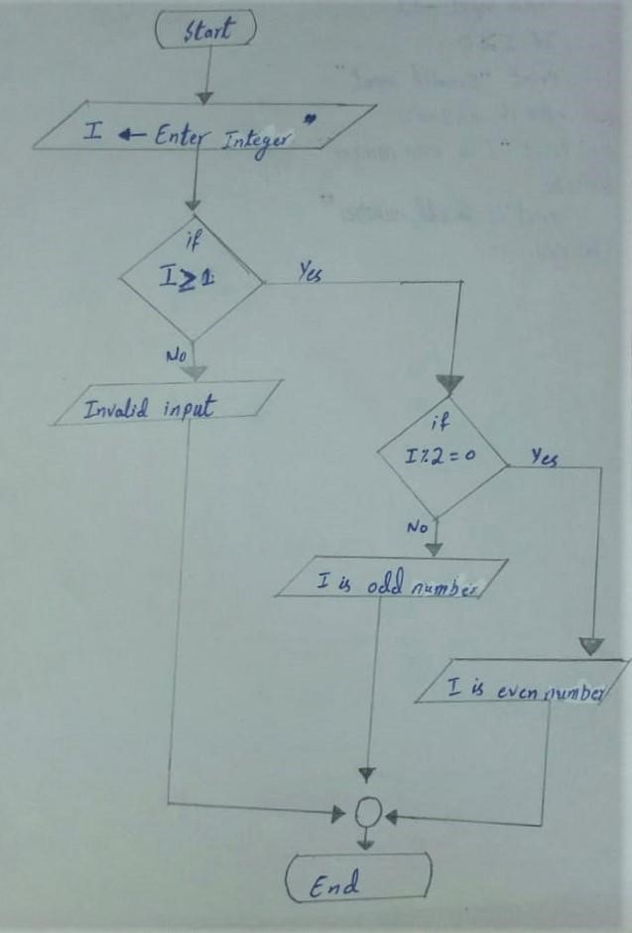

***Pseudocode:***

1. Start
2. Print “Enter Integer” 3. Read inputI
3. If I < 0
4. Print “Invalid input”
5. Else if n%2==0
6. Print “I is Even Number”
7. Else Print “I is Odd Number”
8. End

**Problem 3**: ***Adult or Minor.***

Given the age tell whether a person is an adult or minor. According to some laws in Pakistan, “’child’ means a person who, if a male, is under eighteen years of age, and if a female, is under sixteen years of age.”

***Flowchart:***

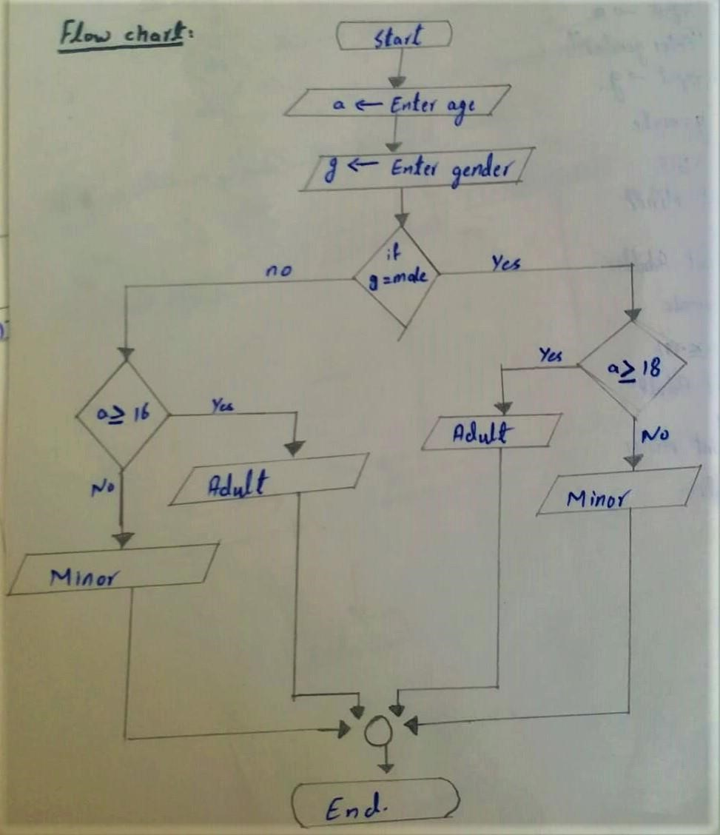

***Pseudocode:***

1. Start
2. Print “Enter Age” 3. Read Inputa
3. Print “Enter Gender”
4. Read Inputg 6. If g=male
5. If a>18
6. Print “Adult”
7. Else
8. Print “Minor”
9. Else if g=female
10. If a>16
11. Print “Adult”
12. Else
13. Print “Minor”
14. End

***Problem 4: Bus fare***

Mr. Bhola has acquired the post of transport minister. The transport mafia has forced him to implement a complex bus fare method which benefits the transporters. Mr. Bhola (as you have by now known, he is weak in mathematics) is unable to calculate the fare correctly. The new fare calculation method suggests that all adults pay a basic fare of PKR 10 and minors pay a basic fare of PKR 5. For every subsequent 5 km adults pay PKR 5/km and minors pay PKR 3/km (First 5km are free after paying basic fare). Adults and minors are determined by the definition in problem 2. Input to the program are traveler’s age, gender, and distance. Output is the total fare. Check for all invalid inputs (e.g., negative distance or age values).

***Flowchart:***

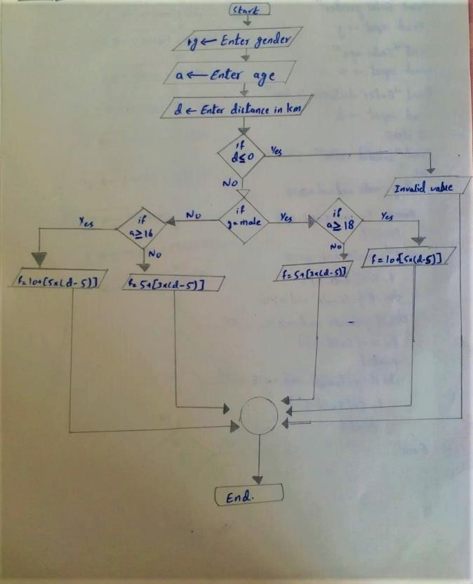

***Pseudocode:***

1. Start
2. Print "Enter gender”
3. Read inputg
4. Print “Enter Age” 5. Read inputa
5. Print “Enter Distance in Kilometer”
6. Read Inputd
7. If d < 0
8. Print “Invalid input”
9. Else if g=male and a > 18
10. F = 10 + {5*(d-5)}
11. Print f
12. Else if g=male and a < 18
13. F = 5 + {3*(d-5)}
14. Print f
15. Else if g=female and a > 16
16. F = 10 + {5*(d-5)}
17. Print f
18. Else if g=female and a > 16
19. F = 5 + {3*(d-5)}
20. Print f
21. End

Problem 5: Which Floor

There are 10 floors in a building 0 to 9. The building lift/elevator has a 1 digit 7 segment LCD Panel display to tell which floor the lift is on, as shown. The input into the LCD Panel is a 7-digit long integer with only 1s and 0s. Each digit of the 7-digit long integer tells which panel to light or not to light from A to G respectively, where 1 means to light the panel and 0 means to keep it off.

E.g., 0110000 means only panel ‘B’ and ‘C’ are lit thus telling that this is the first floor. Similarly, the number 1111110 tells that all panels are lit except panel ‘G’ displaying the number 0.

You need to write a program for a computer surveillance system to tell which floor the lift is on. The input for the program is the 7-digit integer compromising of only 1s and 0s. The output should be a single digit integer 0 to 9 telling which floor the lift is on.

Hint: You can get the last digit by using %10 and the remaining digits by using integer division /10. Also, you only need branching to do it.

***Flowchart:***

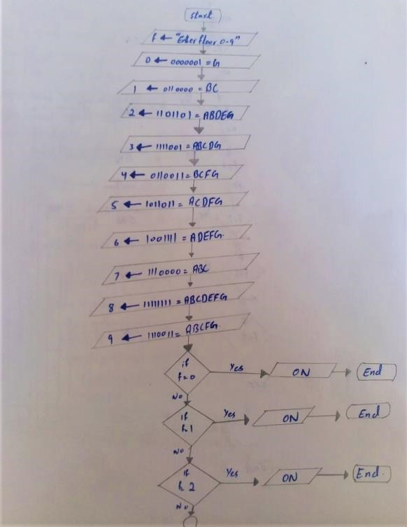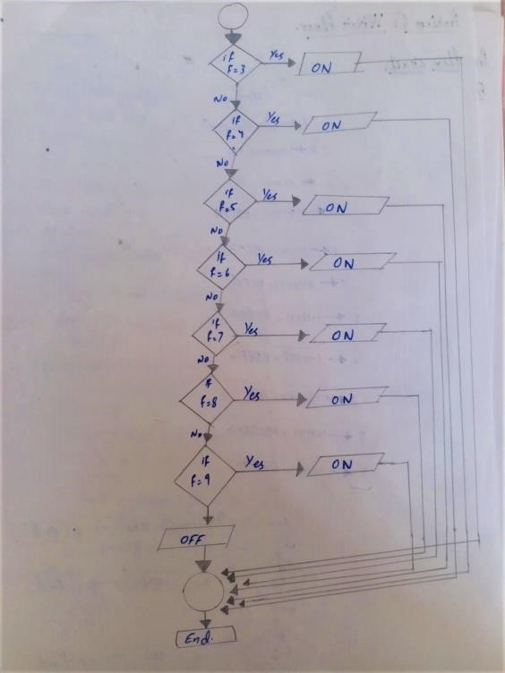

***Pseudocode:***

1. Start
2. Print “Enter Floor 0_9”
3. Read input f
4. 0 0000001=G
5. 1 0110000=BC
6. 2 1101101=ABBDEG
7. 3 1111001=ABCDG
8. 4 0110011=BCFG
9. 5 1011011=ACDFG
10. 6 1001111=ADEFG
11. 7 1110000=ABC
12. 8 1111111=ABCDEFG
13. 9 1110011=ABCFG
14. If f=0
15. Print “ON” 16. else if f=l
16. Print "ON"
17. else if f=2
18. Print “ON”
19. else if f=3
20. Print “ON”
21. else if f=4
22. Print “ON”
23. else if f=5
24. Print “ON”
25. else if f=6
26. print “ON”
27. else if f=7
28. Print “ON”
29. else if f=8
30. Print “ON”
31. else if f=9
32. Print “ON”
33. else
34. Print “OFF” 36. End.

***Problem 6: Sum Digit.***

Using loops sum the digits of a positive number.

Sum Digit (345) → 12 Sum Digit (1) → 1 Sum Digit (1600) → 7

Sum Digit (55) → 10 Sum Digit (400000000) → 4 Sum Digit (0) → 0

***Flowchart:***

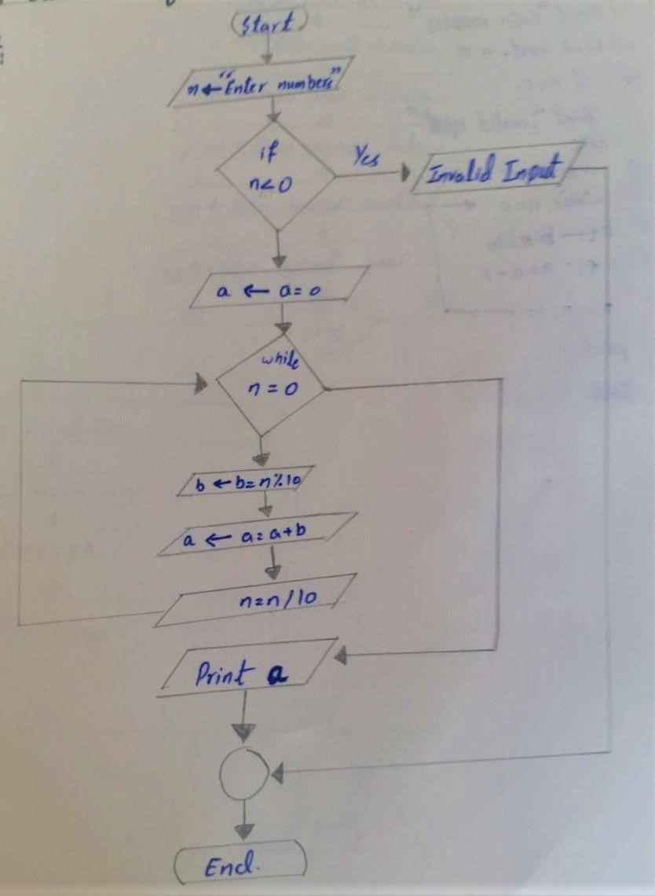

***Pseudocode:***

1. Start
2. Print “Enter Number”
3. Read input n
4. If n < 0
5. Print “Invalid Input”
6. Else
7. a a=0

While n=0

8.

1. b b=n%10
2. a a=a + b
3. n=n/10
4. Print a
5. End

***Problem 7: Exact Age in days, months, and years from Date of Birth:***

Given DOB of an applicant find the exact age in days, months, and years. But first check the DOB and current date for a valid Gregorian date. Use functions were needed.

***Flowchart:***

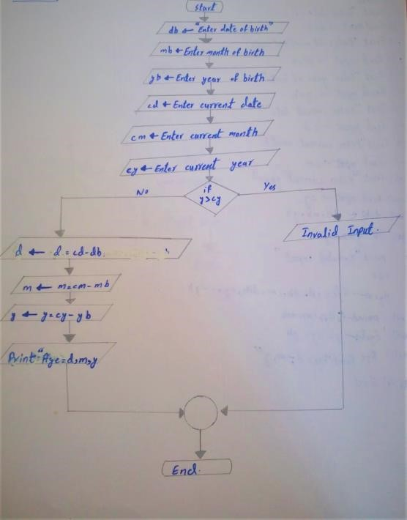

***Pseudocode:***

1. Start
2. Print “Enter date of birth”
3. Read input db
4. Print “Enter month of birth” 5. Read input mb
5. Print “Enter year of birth”
6. Read input yb
7. Print “Enter current date”
8. Read input cd
9. Print “Enter current month”
10. Read input cm
11. Print “Enter current year”
12. Read input cy
13. If yb > cy
14. print “Invalid input”
15. else
16. d d= cd- db
17. m m = cm-mb
18. y y = cy-yb
19. Print “Age = d,m,y”
20. End

***Problem 8: Mean Machine***

Mr. Bhola does not know how to calculate the mean of n numbers. Write a program using a loop that will keep asking Mr. Bhola to enter an integer until he gives as input the number 0. ‘0’ indicates that the input is complete. You can then go on to find and print the mean.

***Flowchart:***

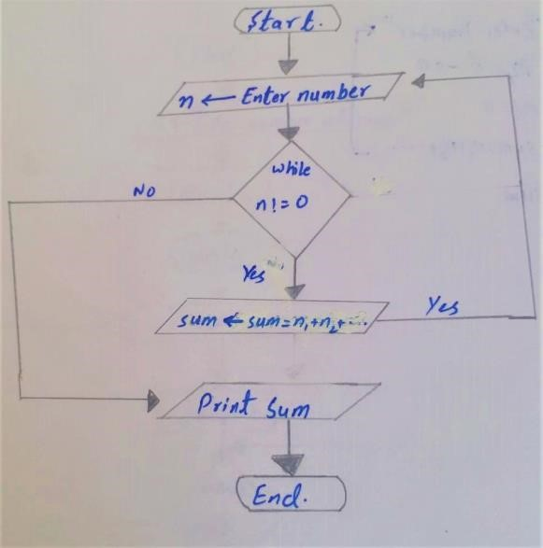

***Pseudocode:***

1. Start
2. Print “Enter Number”
3. Read Input n
4. While n! = 0
5. Sum Sum = N1 + N2 + ...........
6. Print Sum
7. End

***PROBLEM 9: PATTERN PRINTING :***

Mr. Bhola’s wife, Mrs. Bholi has opened a boutique and needs to give the printing company an exact pattern for her new design. She is using the same pattern of different sizes. And worse her designer called in sick. It comes down to your programming skills to help Mrs. Bholi print her patterns. Your program, using loops, must print the pattern below for any value of n where n defines how long the pattern will be.

***Flowchart:***

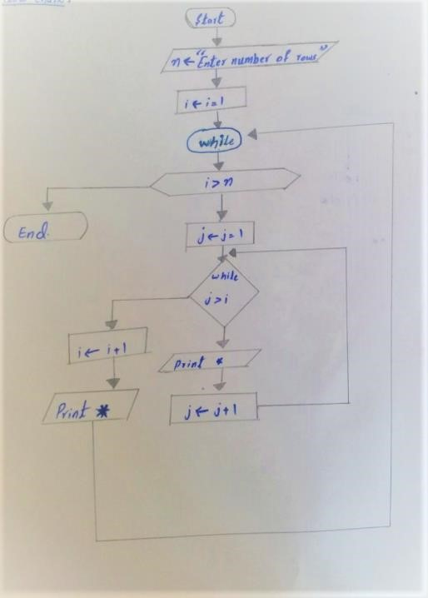

***Pseudocode:***

3.

1.

Start

2.

Print “Enter Number of Rows”

Read input

n

I == 1

While n< I

j==1

7.

While j>I

Yes

i=i+1

8.

j

j+1

9.

Print *

4. i

5.

6. J

10. End